Member of the Month January 2021
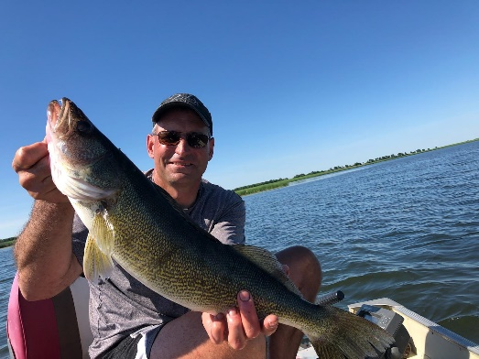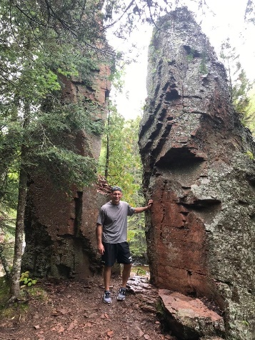
NAME: A Marc Nielsen, MD
Undergraduate School: Concordia College, Moorhead, MN
Medical School: University of North Dakota School of Medicine and Health Sciences
Residency: Altru Family Medicine Residency
Any additional training: Association of Family Medicine Residency Directors National Institute for Program Director Development Fellowship
Current Position/Practice Location: Program Director, Altru Family Medicine Residency
Family: Spouse: Wendy Children: Aaron (20) Tanner (18) Logan (12) Westin (12)

Family Medicine Questions: (please answer 3)
- Why did you choose Family Medicine? The opportunity to provide care for all patients across the spectrum of health care in a rural setting.
- If you weren’t a physician, what do you think you would be doing? Construction management
- What is the best part of your current position/practice? Patient care will always be special. I cherish the opportunity to establish relationships with patients who trust me to provide medical care. My colleagues are exceptional. The opportunity to teach residents is exhilarating, challenging, and fulfilling.
- What makes our mission meaningful to you? As a family medicine physician of 20-years, initially in a rural setting, and now in an educational environment, I have lived the mission statement of the NDAFP.
- What advice would you give to a young physician starting out? Medicine is a commitment to lifelong learning. Enjoy the ride, avoid the politics, and take time for yourself.
Fun Questions: (please answer 3)
- Where’s your favorite place in the world? Fort Peck, MT and Nipawin, SK, Canada
- If you could be an animal, which would it be? Big Horn Sheep
- The last book you read? Into the Darkness, L.T. Ryan
- What are you currently binge watching? Yellowstone
- What is your secret talent that no one knows about? Cooking/grilling
- Which superpower would you most like to have? Superman
- How many states have you visited? 23

