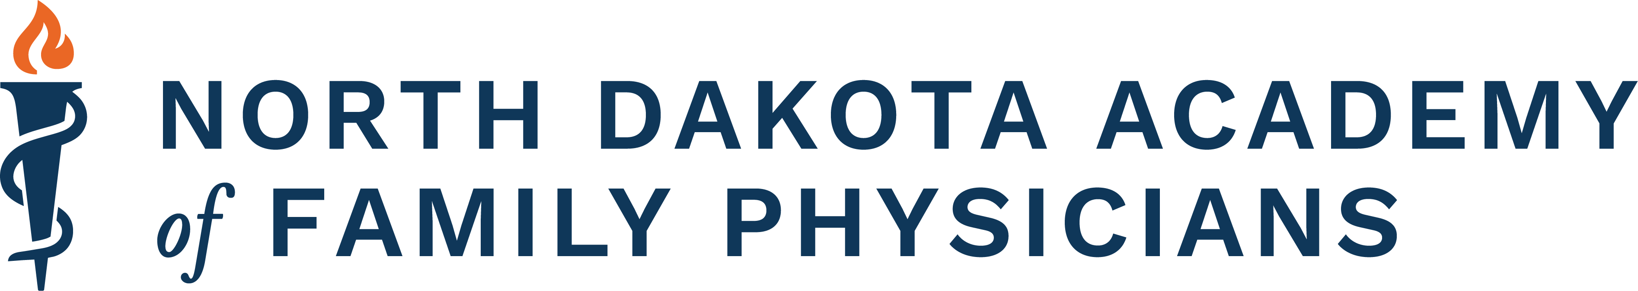
FAMILY MEDICINE UPDATE - BIG SKY, MT

PO Box 426, Hazen, ND 58545, (701) 772-1730, brandy@ndafp.org

Hayley Svedjan, MD – Committee Chair Brandy Jo Frei, CAE – Conference Coordinator
Patrick Moore, MD – Committee Member Makoto Tsuchiya, ATC – AV/Tech Specialist
Jacinta Klindworth, MD – Committee Member
Ashlyn Kamrath, MD – Committee Member

TO: ALL PARTIES INTERESTED IN SUPPORTING THE FAMILY MEDICINE UPDATE

FROM: FAMILY MEDICINE UPDATE PLANNING COMMITTEE:

RE: Exhibiting and Support of the 2026 Family Medicine Update Conference in Big Sky, MT

We appreciate the continued support received during the Family Medicine Update Conference and look forward to your participation in the 49th Annual Family Medicine Update Conference being held January 19 -22, 2026. This CME conference is an excellent opportunity to visit with family physicians from across the region. There are typically 150 medical professionals from 26 states represented by conference attendees.

There are numerous opportunities to support the NDAFP and the Family Medicine Update Conference. There will once again be an exhibit hall along with the opportunity to sponsor additional aspects of the conference.

Exhibit times will be as follows:
Sunday – Setup begins at 3pm
Monday – Thursday: the exhibit room will be open from 7:00 a.m.- 10:00 a.m. and from 4:00 p.m. - 6:30 p.m. Over the course of the four days, you will have an opportunity to visit with all of the attendees.

Monday evening there will also be a welcome reception from 6:45 p.m. – 8:00 p.m. During this time the exhibit hall will be open and the attendees, as well as their families, will be enjoying a wonderful evening reception. This is an excellent opportunity to visit with the physicians when they are not attending lectures.

Each exhibit will have one skirted table, 8 feet long, with 2 chairs. There is limited space available in these rooms. The tables will be claimed on a first come first serve basis.

Dress code for everyone will be casual. Sweaters and ski wear will be appropriate. We would discourage suits and dresses.

Pertinent items related to or useable during the time of the conference can be distributed. Do not bring large amounts of promotional materials that may require a lot of space to get home as the majority of attendees will be flying in. Very large professional displays are discouraged. Tabletop displays are a better format for this room.

Exhibiting will be limited to the first 20 companies that express an interest and provide payment to the NDAFP. Please contact Brandy Jo Frei, (Telephone: (701) 772-1730 / Email: Brandy@ndafp.org) to reserve your table today.

REGISTRATION FORM
- Exhibit -
Family medicine Update 2026

Yellowstone conference center, Big Sky, MT
January 19-22, 2026

Company Name ________________________________________________

Rep. Names ________________________________________________

________________________________________________

Main Contact ___________________________________________________

Address _______________________________________________________

City ____________________________State _______ Zip ______________

Phone _________________________

Email Address ___________________________________

Support Opportunities:

Exhibit Fee $ 1,000 _____
Break Sponsor $ 750 _____

Speaker Sponsor $ 3,000 _____

Family Movie $ 500 _____

Welcome Reception $ 1,000 _____

General Mtg Support $ ____________

Total $ ______________

If paying my check, please make checks payable to NDAFP
All credit cards are also accepted.
Tax ID # 45-6013505

Please send this form and payment to: Contact Info:
NDAFP Brandy Jo Frei
PO Box 426 Phone: 701-772-1730
Hazen, ND 58545 Email: Brandy@ndafp.org

