Member of the Month – May 2020
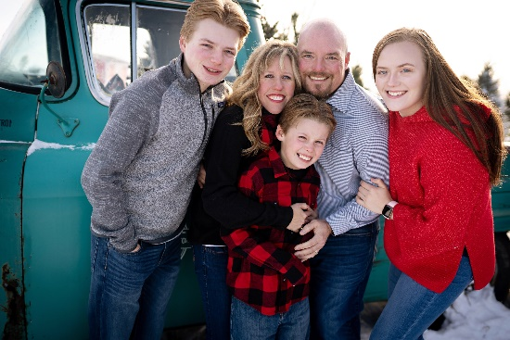
NAME: Heidi Philpot
Undergraduate School: UND
Medical School: UND
Residency: Altru Family Medicine Residency
Current Position/Practice Location: Family Physician/ Associate Program Director at Altru Family Medicine Residency
Family: Husband Len (20 years in June!), Kacy Jo (17), Bryce (15) and Brock (9)
Family Medicine Questions:
- Why did you choose Family Medicine?
I love the relational aspect of family medicine! Patients let you into their lives and you walk with them through all moments, some are great and some are really hard, but it is a privilege to be there with them through it all. I also enjoy the intellectual challenges of family medicine. Not a day goes by where I am not learning new things!

- If you weren’t a physician, what do you think you would be doing?
I would either be an offensive coordinator for a high school football team or living out in the country on a ranch raising my family.

- What is the best part of your current position/practice?
I LOVE working at a residency program because you get to watch a family physician be born over three years. Watching residents’ development and maturation as well as being around their compassion, excitement and intellectual curiosity helps to remind me daily why I do this job. Also, I have amazing partners that I love getting to do work with each day. We share lots of laughs, a few tears and yes even a few disagreements together but I am grateful for their influence on my life and for providing real life examples of great family physicians!
Fun Questions:
- The last book you read?
“Cilka’s Journey” by Heather Morris. It is a sequel to “The Tattooist of Auschwitz”. I enjoy reading historical fiction and both novels provide a glimpse into the power of the human spirit to overcome in the face of the unspeakable horrors.

- What are you currently binge watching?
“The Last Dance” on ESPN and we just finished the 2 seasons of “Formula 1: Drive to Survive” on Netflix. I can binge watch anything sports related!

